Kazon Wilson

Project 2

**Setting up Groovy on Windows 10**

1. **Download and install Java JDK 8**
   1. Go to <http://www.oracle.com/technetwork/java/javase/downloads/jdk8-downloads-2133151.html>.
   2. Scroll down to “Java SE Development Kit 8u162”. Tick the box next to “Accept License Agreement” then select the installation file for your OS. (In my case I chose Windows x64).
   3. Run the installation, click next on all options and click install
   4. (IMPORTANT: Do not skip this step or your environment variables will work correctly!) Restart your machine to finalize the installation.
2. **Download and install Groovy 3.0**
   1. Head over to <http://groovy-lang.org/download.html>. Scroll to Groovy 3.0 and click “Windows Installer” 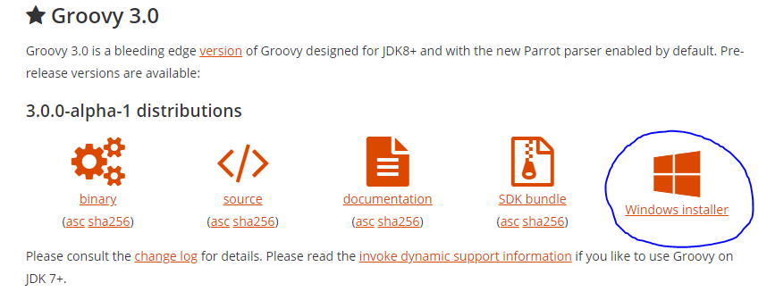
   2. Run the installation, click next on all options and click install.
3. **Set up your environment variables**
   1. Pull up the windows menu search “View advanced system settings” and click on it.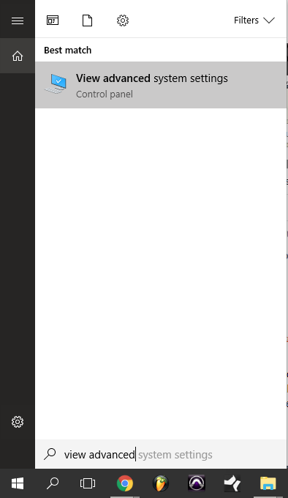
   2. Click on the advanced tab and click “Environment Variables”. Go to “System variables” and click on “New…”
   3. Name the variable *Java_Home*and set the variable value to *C:\Program Files\Java\jdk1.8.0_162* if you installed the 64-bit version of the Java JDK or *C:\Program Files (x86)\Java\jdk1.8.0_162* for the 32-bit version.
   4. In the user variable box, click on the “Path” variable and click “Edit…”. Click New and type “%GROOVY_HOME%\bin”
   5. Once you are finished click on OK in Environment Variables box and click on OK in the system properties box.
4. **Compile and execute the program**
   1. Once you are done installing the Java JDK and Groovy and setting up your environment variables, simply open your favorite code editor (I used VSCode).
   2. Create a file copy and paste my program into it and save it as a .groovy file.
   3. Open an instance of the CMD prompt.(Click the windows button and search “CMD”)
   4. Type “cd (enter the directory that your script is saved in here)”. For example, I typed “cd C:\Users\kazon\Documents\CSCI3210\Project2”
   5. Once you are in the correct directory type “groovy (enter script name here)” e.g. “groovy project2”

**Project Demonstration**

[**https://youtu.be/4GwGEWwcyYc**](https://youtu.be/4GwGEWwcyYc)